Geometry: Unit 9, Lesson 6

- What is the value of $\sqrt[3]{64000}$?

$$40$$

- What is the value of $7^{3}$?

$$343$$

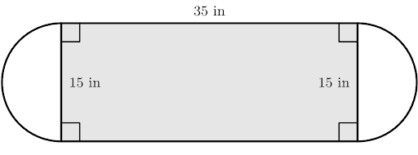
- The composite figure of two semicircles and a rectangle is shown where the dimensions of the rectangle are $35$ inches $(in.)$ by $15 in.$ What is the area of the composite figure?

$$701.625 inches^{2}$$

